**Hyperparameter Database Project**

**Team DB-04 (Tejas Munot, Manasa Vanga)**

**Abstract:**

When an employee at any company starts work, they first need to obtain the computer access necessary to fulfill their role. It is often the case that employees figure out the access they need as they encounter roadblocks during their daily work. A supervisor then must take time out of his busy schedule to manually grant the needed access. As employees move throughout a company, this access discovery/recovery cycle wastes a nontrivial amount of time and money, which we as a team are trying to reduce.

There is a considerable amount of data regarding an employee’s role within an organization and the resources to which they have access. Given the data related to current employees and their provisioned access, models can be built that automatically determine access privileges as employees enter and leave roles within a company. These auto-access models seek to minimize the human involvement required to grant or revoke employee access.

Thus, we have analyzed the data and put the results of the models and algorithms into a physical database. The practical use cases, functions and stored procedures

**Objective:**

The objective of this project is to build a physical database storing details and values of the various hyperparameters generated through running the dataset into H2O. Finally, this database would help support a website which would help data enthusiasts get the best hyperparameter values for their respective datasets.

We are a team of 4 students, 2 aspiring data scientists, Prakruthi and Urja, and 2 database engineers, myself and Manasa. The data science (DS) team plans to use H2O which is a fully open source, distributed in-memory machine learning platform with linear scalability. H2O supports the most widely used statistical & machine learning algorithms including gradient boosted machines, generalized linear models, deep learning and more. H2O also has an industry leading AutoML functionality that automatically runs through all the algorithms and their hyperparameters to produce a leaderboard of the best models.

Here’s how the process flow looks for the team:

1. Conceptual Diagram
2. ER – Diagram
3. Normalization
4. Revised ER – Diagram
5. Converting JSON files into csv files based on the model
6. Creating the physical database
7. Writing practical use cases
8. Documentation and Professionalism

The objective for the loading the data in the physical database was to convert the JSON files into comma-separated value files (csv’s). We did that using python. We then identified the entities, attributes, and relationships. Thus, we came up with the first version of our conceptual diagram.

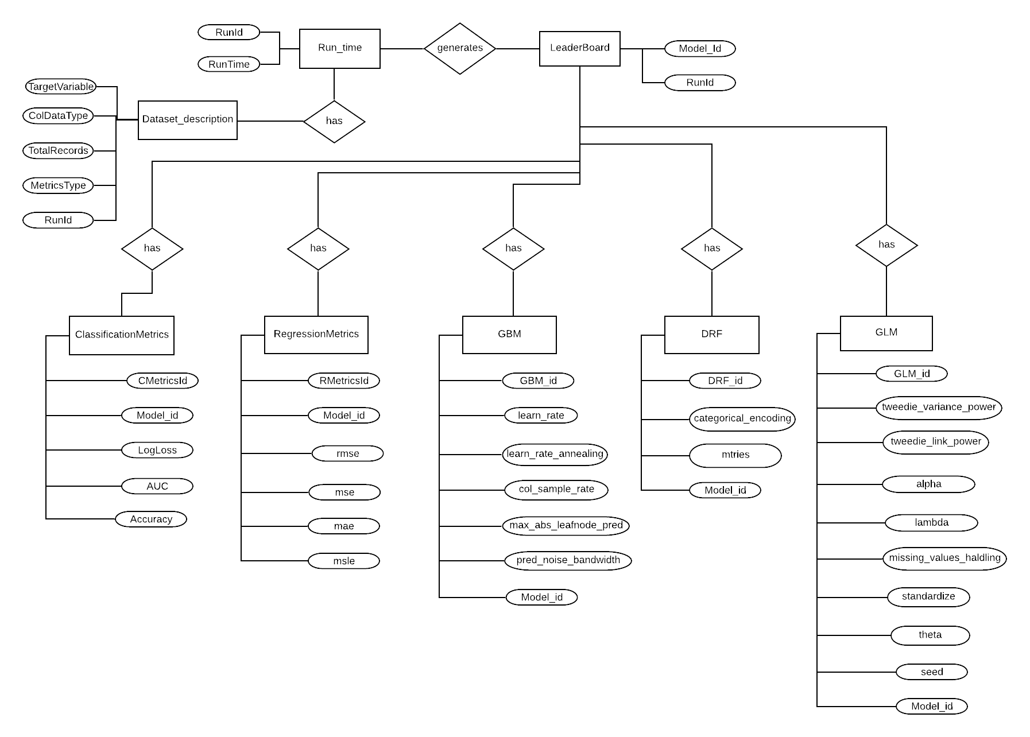

Conceptual Diagram — Iteration 1

But, as it always does, our conceptual diagram evolved throughout the course of the project. As we went ahead and addressed the uses cases for the database, we had to change the conceptual diagram. After a lot of iterations, we came up with a final Entity Relationship Diagram as follows:

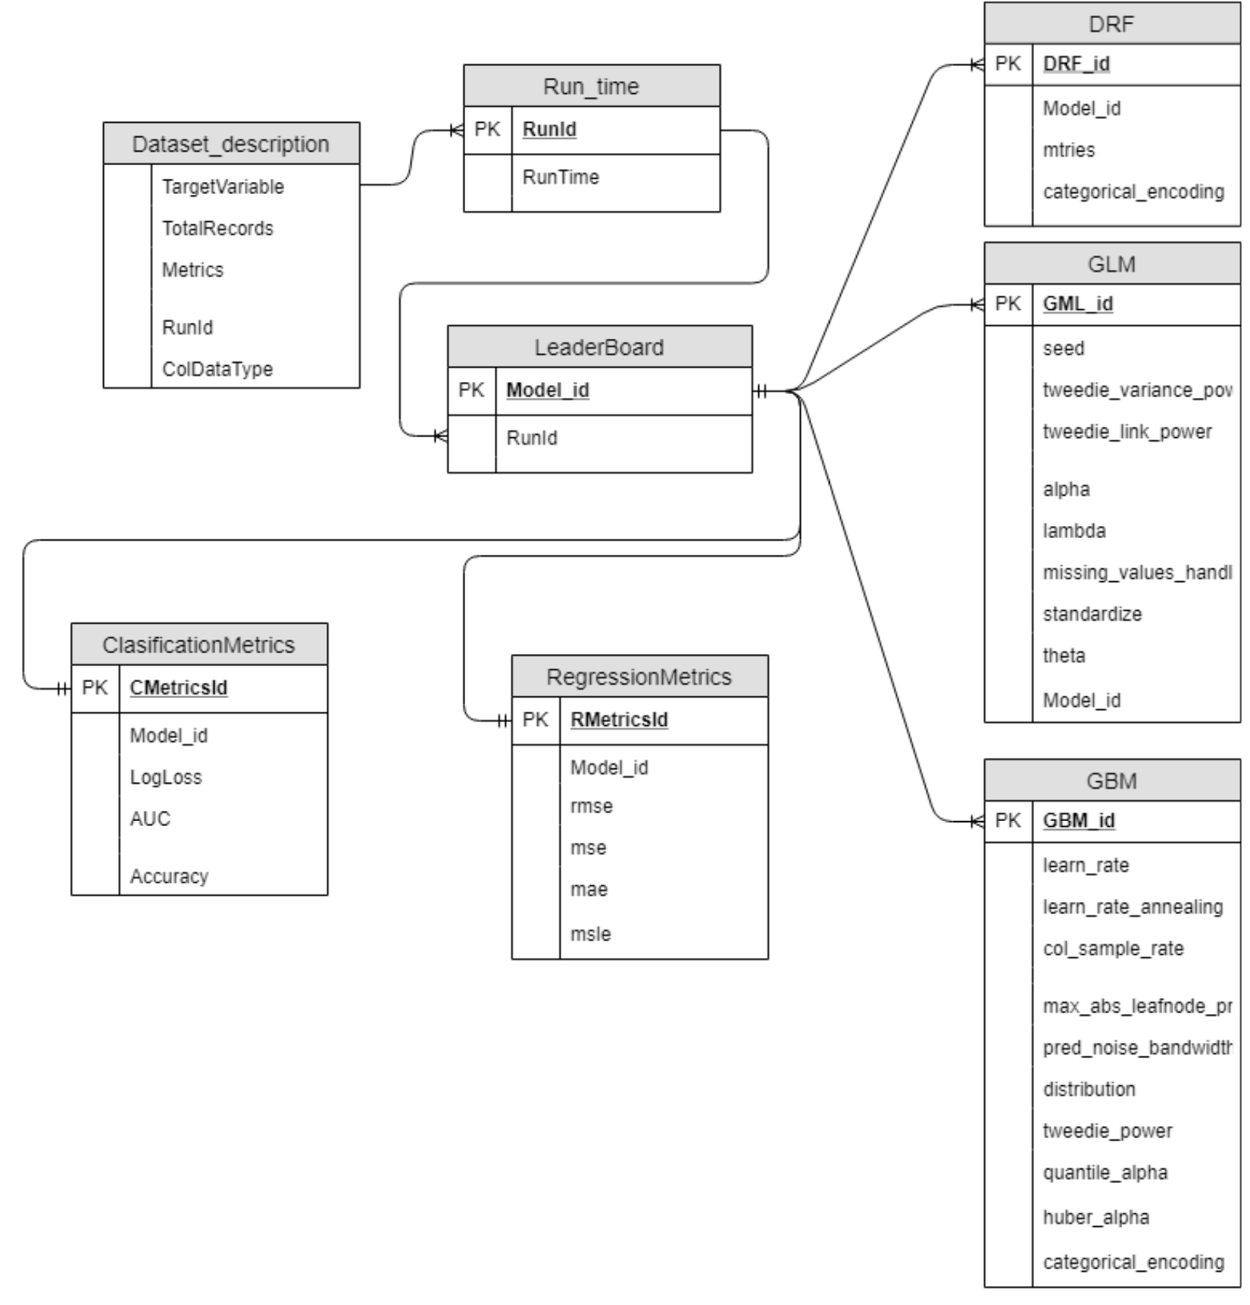

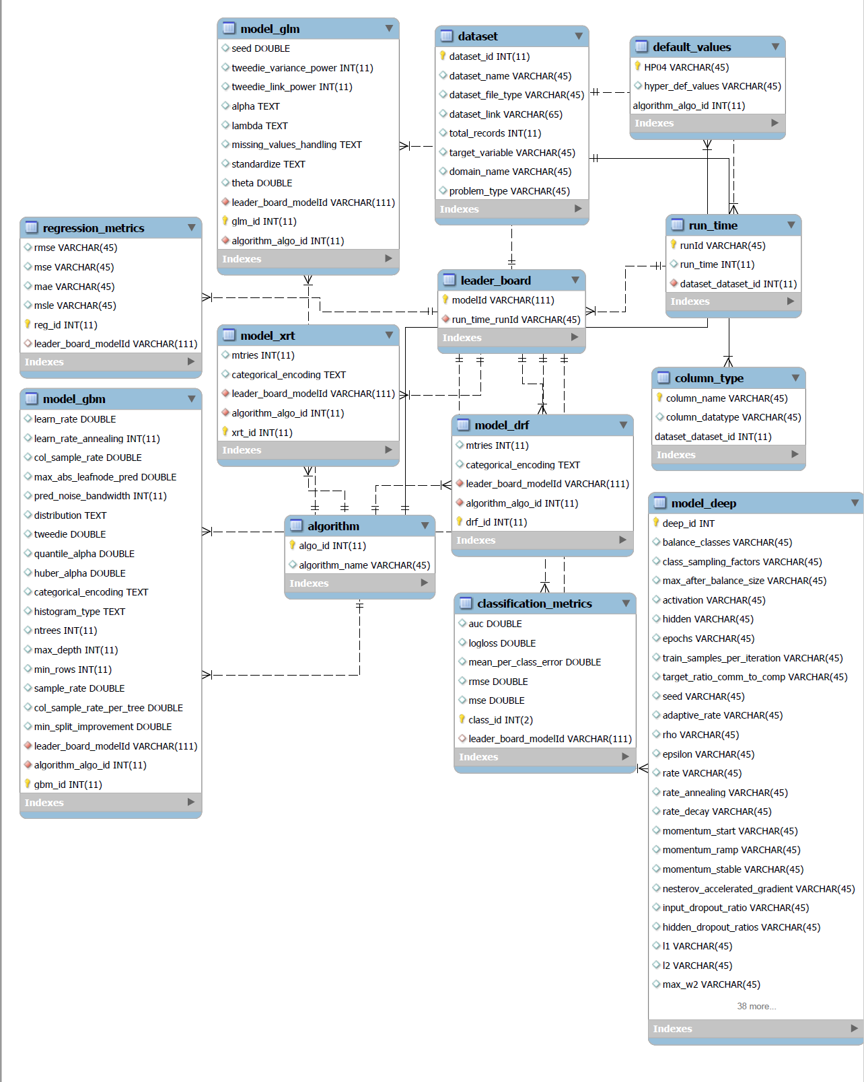

ERD final image

We were now ready to create the physical database. We used MySQL Workbench extensively. All our queries are written and executed in MySQL Workbench.

**Use Cases:**

1) What is the maximum accuracy from all the generated models?

SELECT MAX(auc) AS MAX_AUC, leader_board_modelId

FROM classification_metrics;

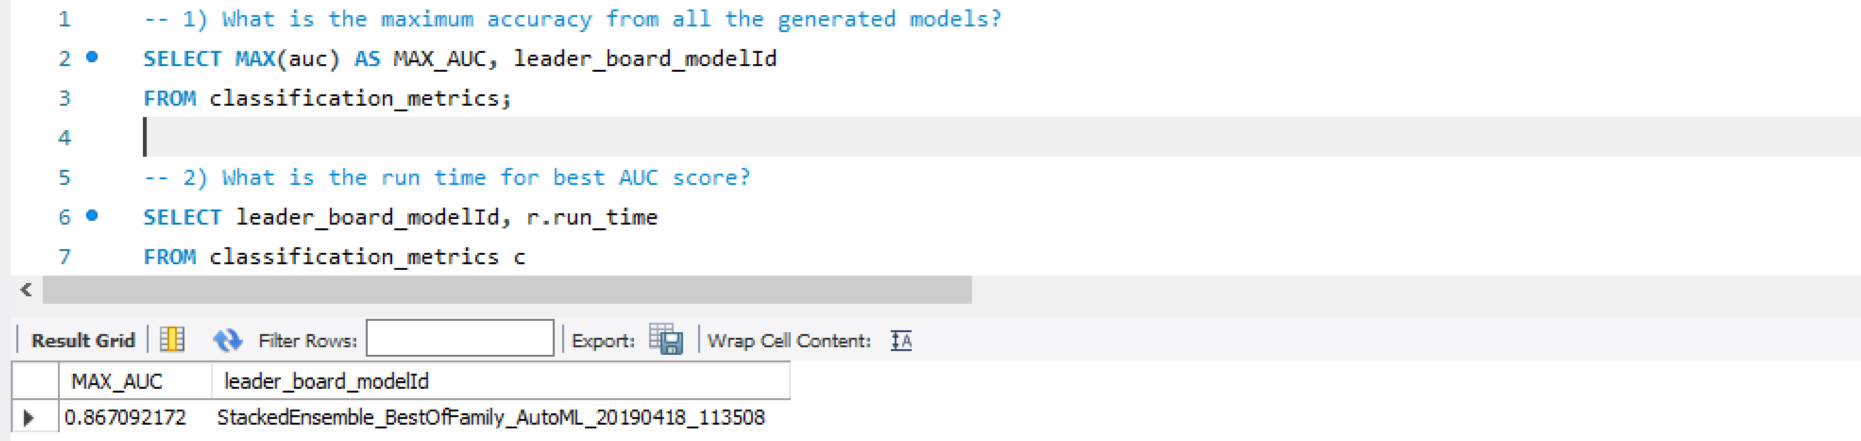

2) What is the run time for best AUC score?

SELECT leader_board_modelId, r.run_time

FROM classification_metrics c

JOIN leader_board l ON l.modelId = c.leader_board_modelId

JOIN run_time r ON r.runID = l.run_time_runId

WHERE auc = (SELECT MAX(auc)

FROM classification_metrics);

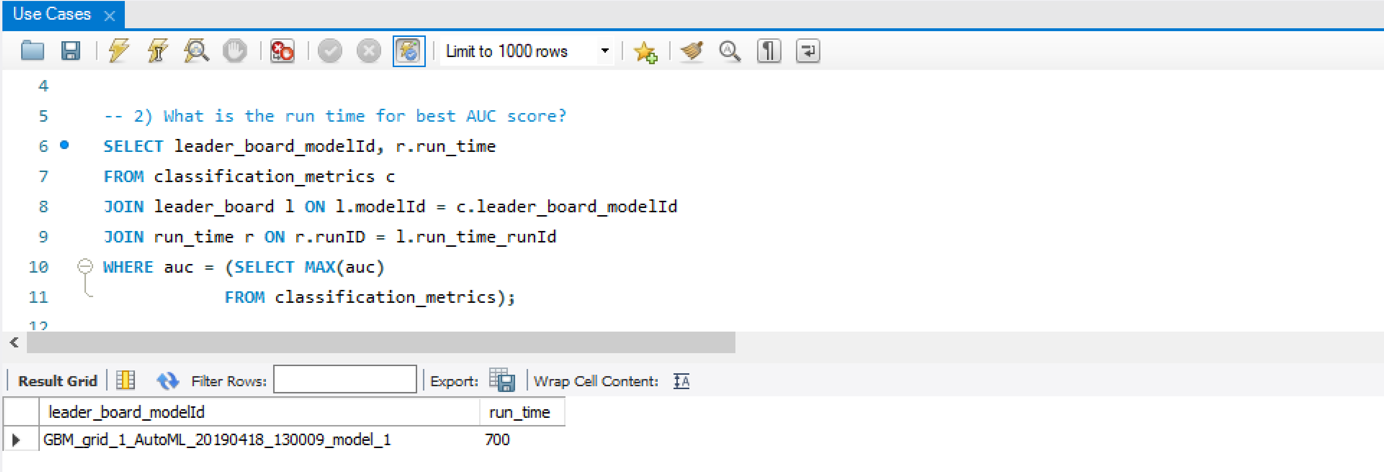

Q3) Which model ID gives the best log loss value? (To check whether Best AUC and logloss belong to the same model?)

SELECT leader_board_modelId, logloss, auc

FROM classification_metrics

ORDER BY 2

LIMIT 1;

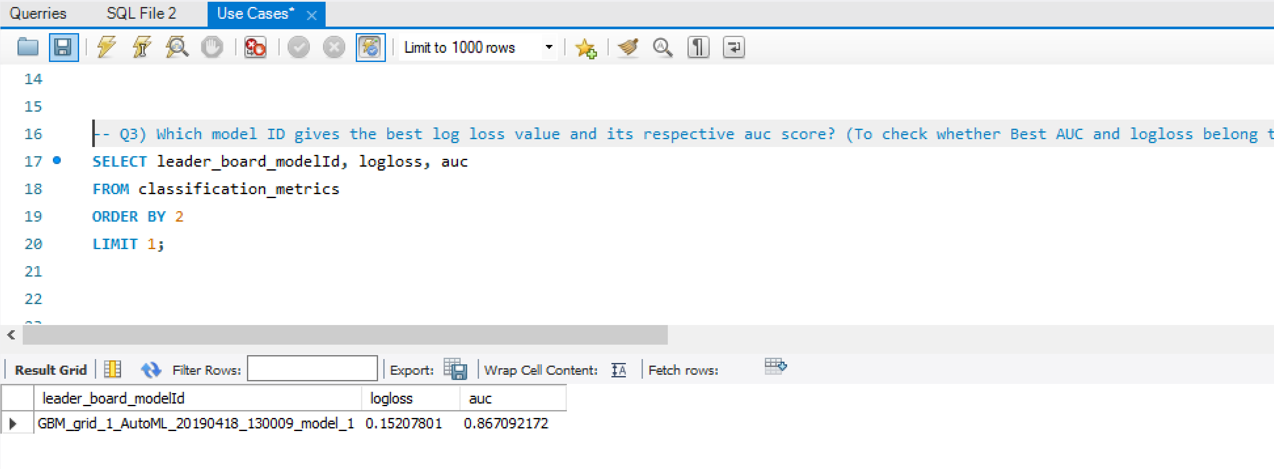

Q4) What are the columns and its datatypes for the used dataset (given to H2O)?

SELECT column_name, column_datatype

FROM column_type

WHERE dataset_dataset_id = 1;

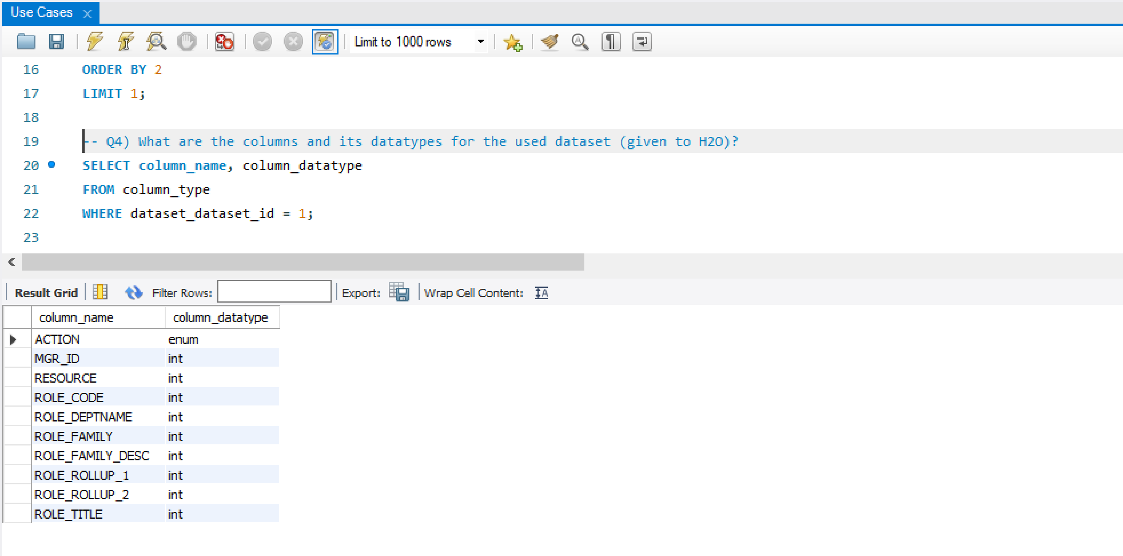

Q5) What is the best algorithm for classification type?

SELECT LEFT(leader_board_modelId,3) AS Algo_Name

FROM classification_metrics c

JOIN leader_board l ON l.modelId = c.leader_board_modelId

WHERE auc = (SELECT MAX(auc)

FROM classification_metrics);

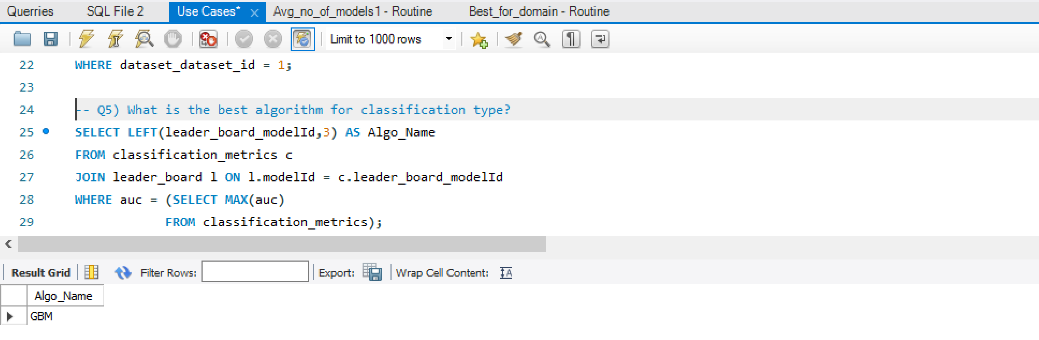

Q6) Get the Max value of the max_depth hyperparameter

SELECT max_depth, leader_board_modelId

FROM model_gbm

ORDER BY 1 DESC

LIMIT 1;

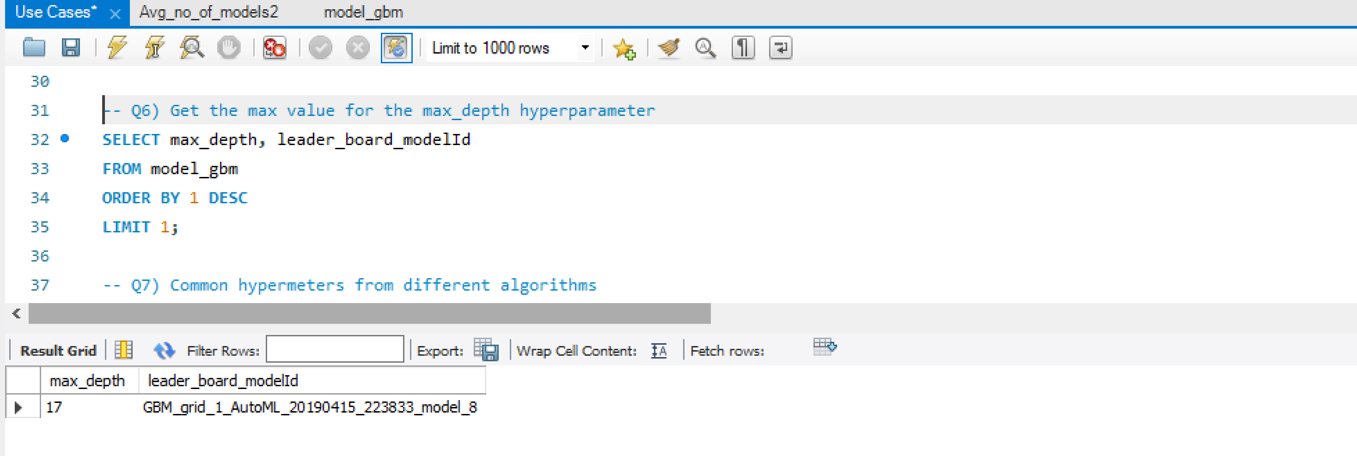

Q7) Common hypermeters from different algorithms

SELECT a.HP04,b.algorithm_name FROM hp04.default_values as a,hp04.algorithm as b

WHERE a.algorithm_algo_id = b.algo_id

GROUP BY a.HP04

HAVING COUNT(a.HP04) > 1;

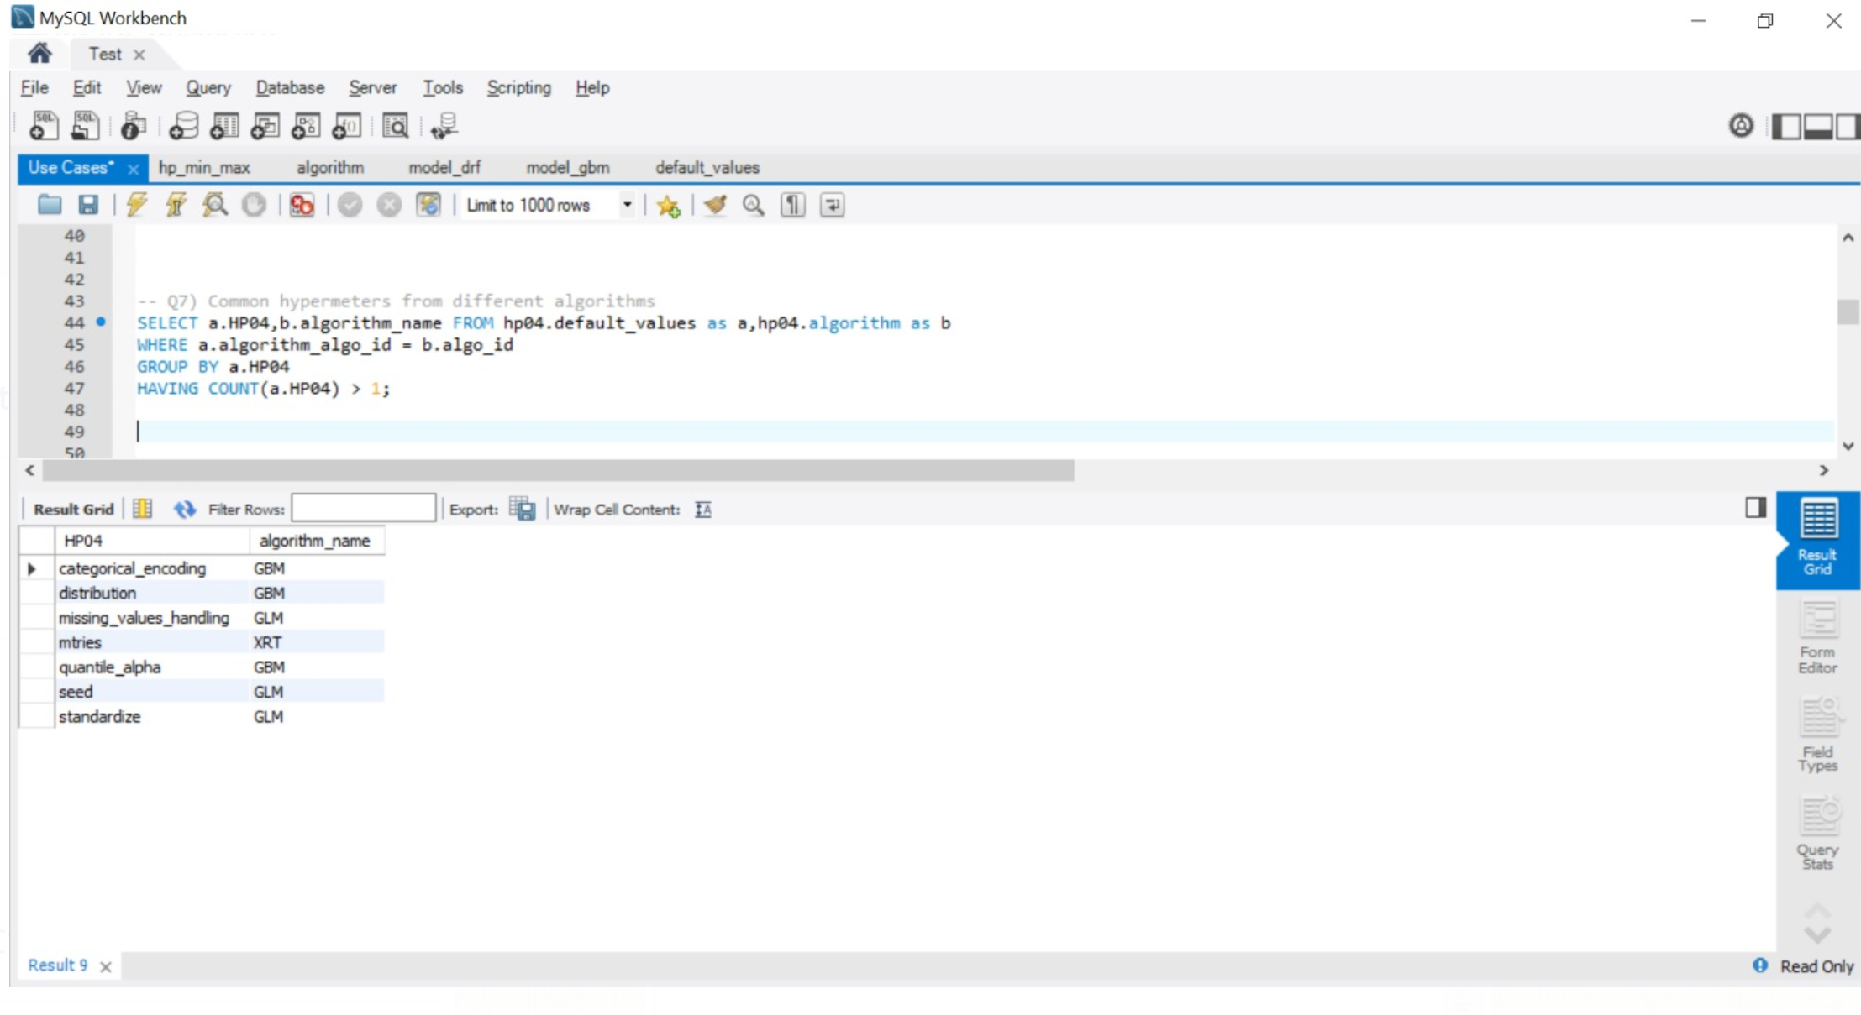

Q8) What are the important parameters for a particular model?

SELECT a.HP04,b.algorithm_name from hp04.default_values as a,

hp04.algorithm as b where importance = 'Y' AND a.algorithm_algo_id = b.algo_id;

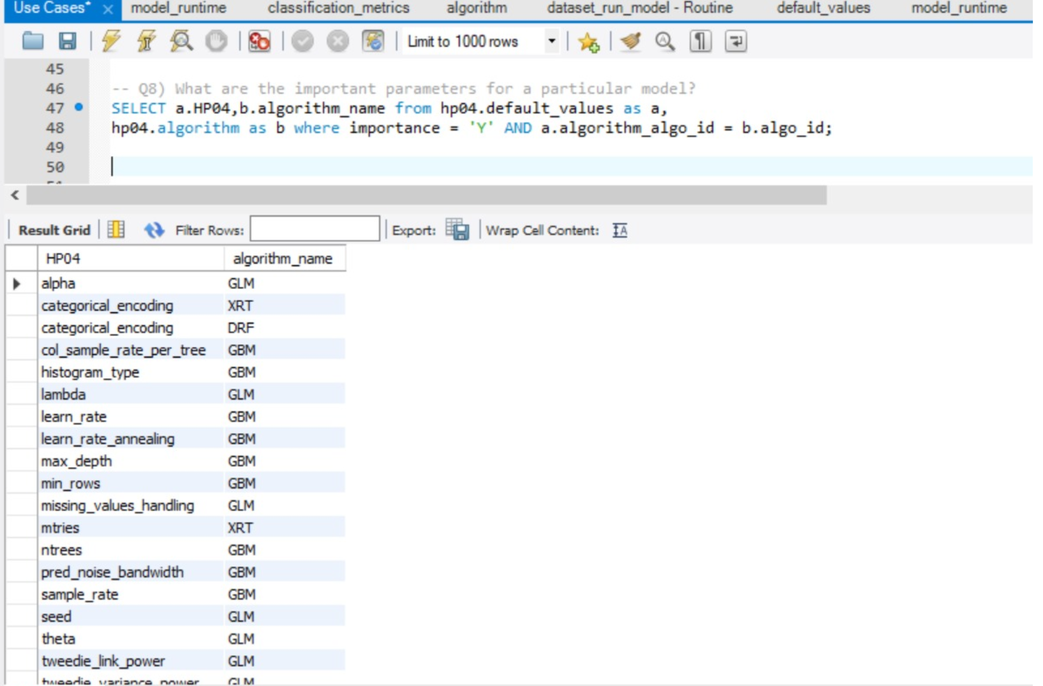

Q9) BEST model based on rmse score:

SELECT leader_board_modelId, rmse as Root_Mean_Square_Error

FROM hp04.classification_metrics

ORDER BY 2

LIMIT 1;

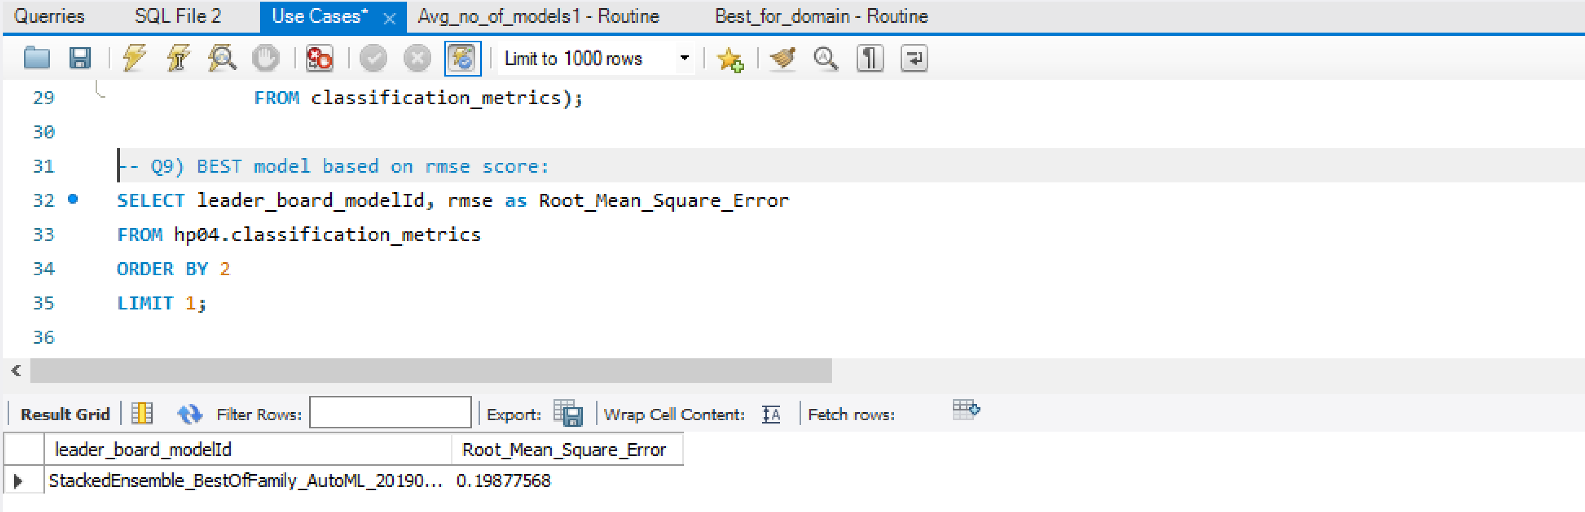

Q10) Default values for common hyperparameters across different algorithms

SELECT a.HP04,b.algorithm_name,a.hyper_def_values FROM hp04.default_values as a,hp04.algorithm as b

WHERE a.algorithm_algo_id = b.algo_id

GROUP BY a.HP04

HAVING COUNT(a.HP04) > 1;

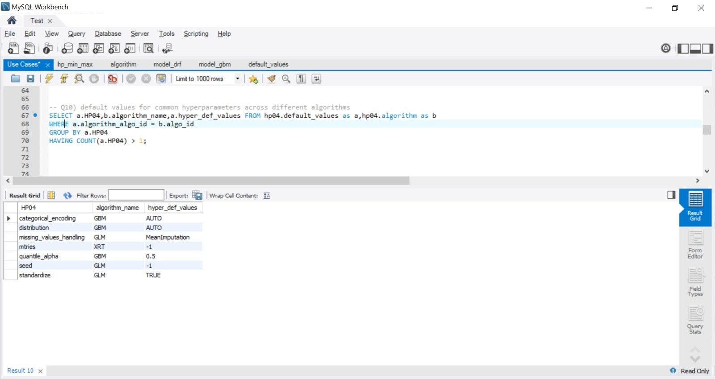

**Functions and stored procedures:**

1. Best model for the given domain with its hyperparameters.

Input: Domain Name

Output: The best model with its actual hyperparameter values

CODE:

DELIMITER $$

CREATE DEFINER=`root`@`localhost` PROCEDURE `Best_for_domain`(IN domain_name1 VARCHAR(45))

BEGIN

DECLARE model VARCHAR(111);

SELECT c.leader_board_modelId INTO model

FROM classification_metrics c

JOIN leader_board l ON l.modelId = c.leader_board_modelId

JOIN run_time r ON r.runID = l.run_time_runId

JOIN dataset d ON r.dataset_dataset_id = d.dataset_id

WHERE domain_name = domain_name1

AND auc = (SELECT MAX(auc)

FROM classification_metrics);

IF(LEFT(model,3) = 'GBM')

THEN

SELECT * from model_gbm WHERE leader_board_modelId = model;

ELSEIF(LEFT(model,3) = 'GLM') THEN

SELECT * from model_glm WHERE leader_board_modelId = model;

ELSEIF(LEFT(model,3) = 'DRF') THEN

SELECT * from model_drf WHERE leader_board_modelId = model;

ELSEIF(LEFT(model,3) = 'XRT') THEN

SELECT * from model_xrt WHERE leader_board_modelId = model;

END IF;

END$$

DELIMITER ;

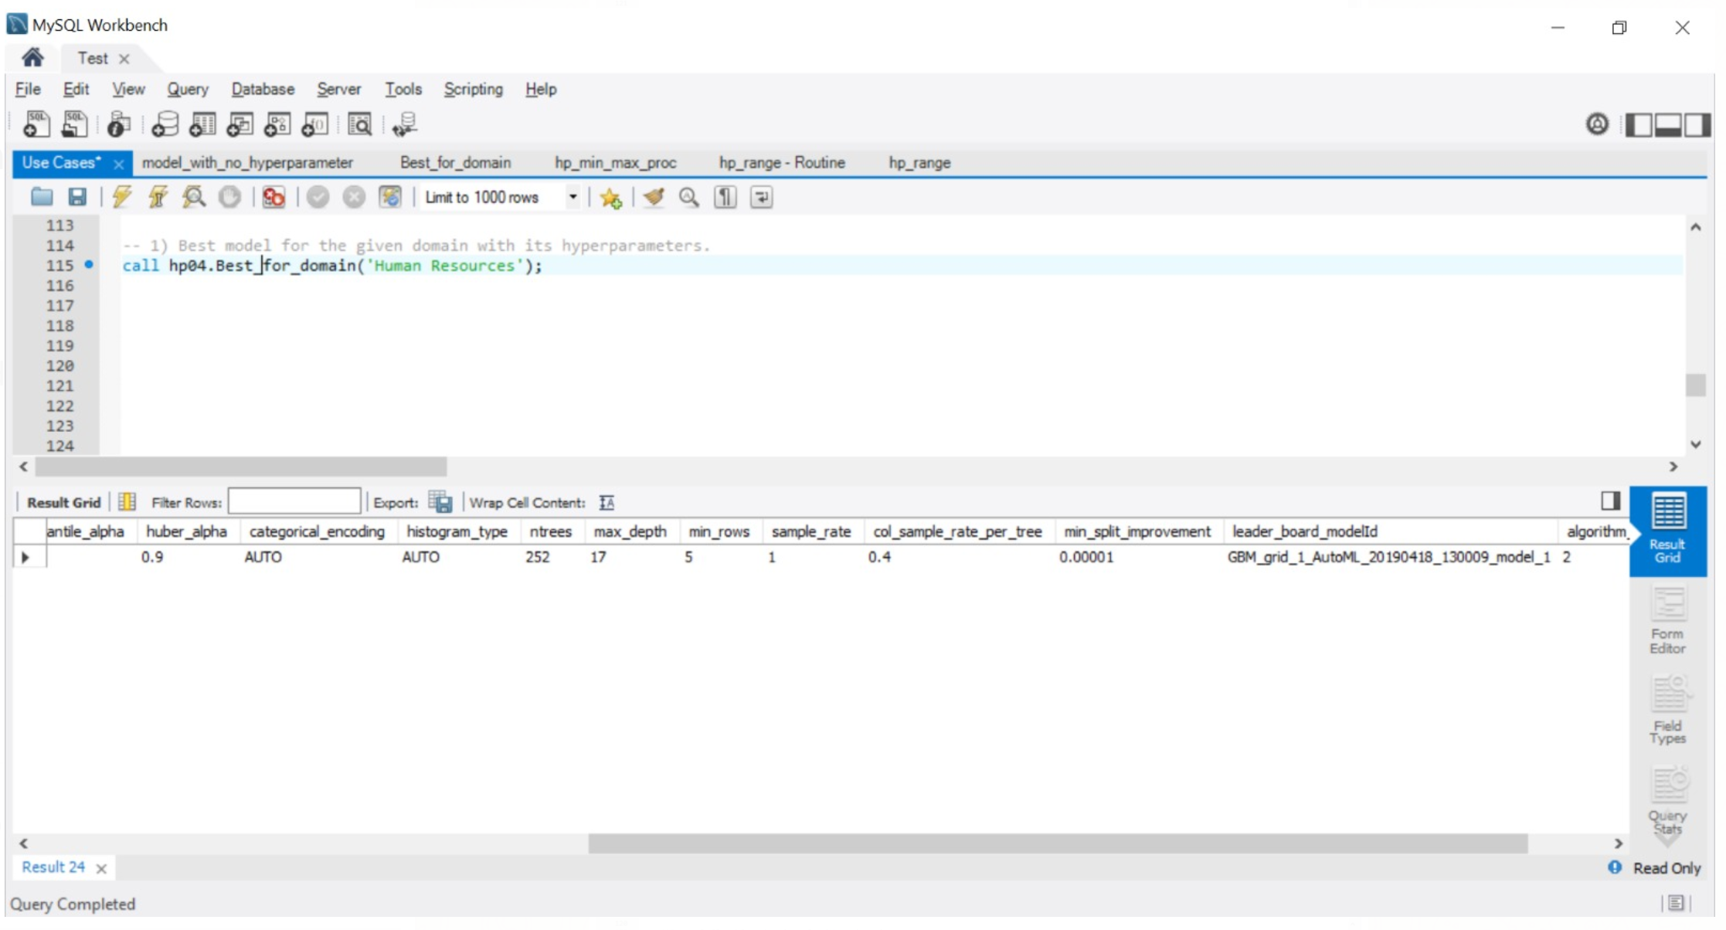

1. What are the minimum and maximum values of learn_rate, ntrees hyperparameter?

Input: Hyperparameter – learn_rate or ntrees

Output: Minimum and Maximum values of learn_rate or ntrees

CODE:

DELIMITER $$

CREATE DEFINER=`root`@`localhost` PROCEDURE `hp_min_max_proc`(IN parameter varchar(100))

BEGIN

DECLARE default_value varchar(45);

select distinct HP04 from hp04.default_values;

IF (parameter = 'learn_rate') THEN

SELECT leader_board_modelId,'learn_rate' as hp_name, min(learn_rate) as minimum,max(learn_rate) as maximum from hp04.model_gbm;

ELSEIF(parameter = 'ntrees') THEN

SELECT leader_board_modelId,'ntrees' as hp_name, min(ntrees) as minimum,max(ntrees) as maximum from hp04.model_gbm;

END IF;

END$$

DELIMITER ;

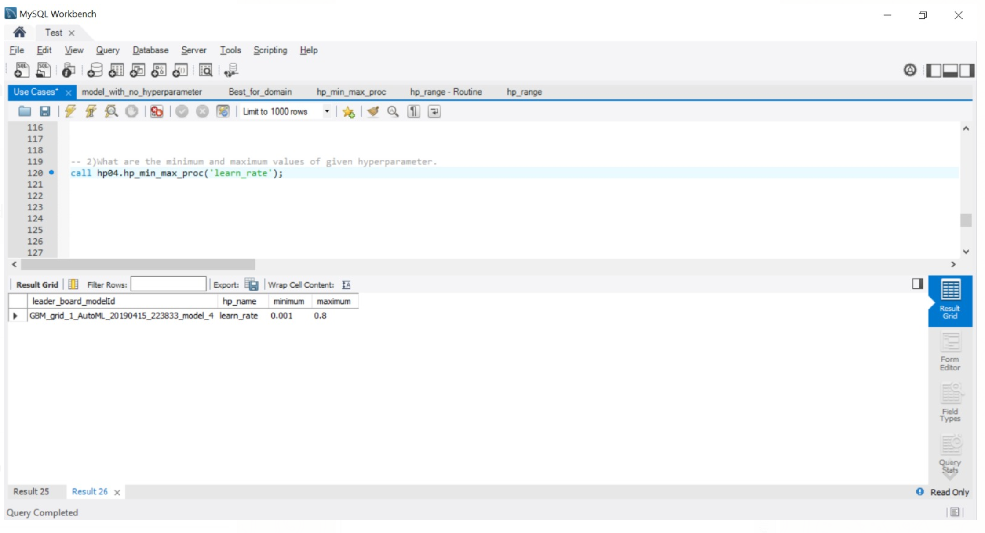

1. Count of all models under given algorithm and runtime.

Input: Algorithm name, runtime

Output: Number of models created for that model and runtime

CODE:

DELIMITER $$

CREATE DEFINER=`root`@`localhost` FUNCTION `Avg_no_of_models1`(algorithm_name VARCHAR(45), run_times INT(11)) RETURNS decimal(10,0)

DETERMINISTIC

BEGIN

DECLARE lvl decimal(10);

SELECT COUNT(*) AS Total_models INTO lvl

FROM leader_board l

JOIN run_time r ON l.run_time_runId = r.runId

WHERE LEFT(modelId,3) LIKE concat(algorithm_name,'%')

AND r.run_time = run_times;

RETURN (lvl);

END$$

DELIMITER ;

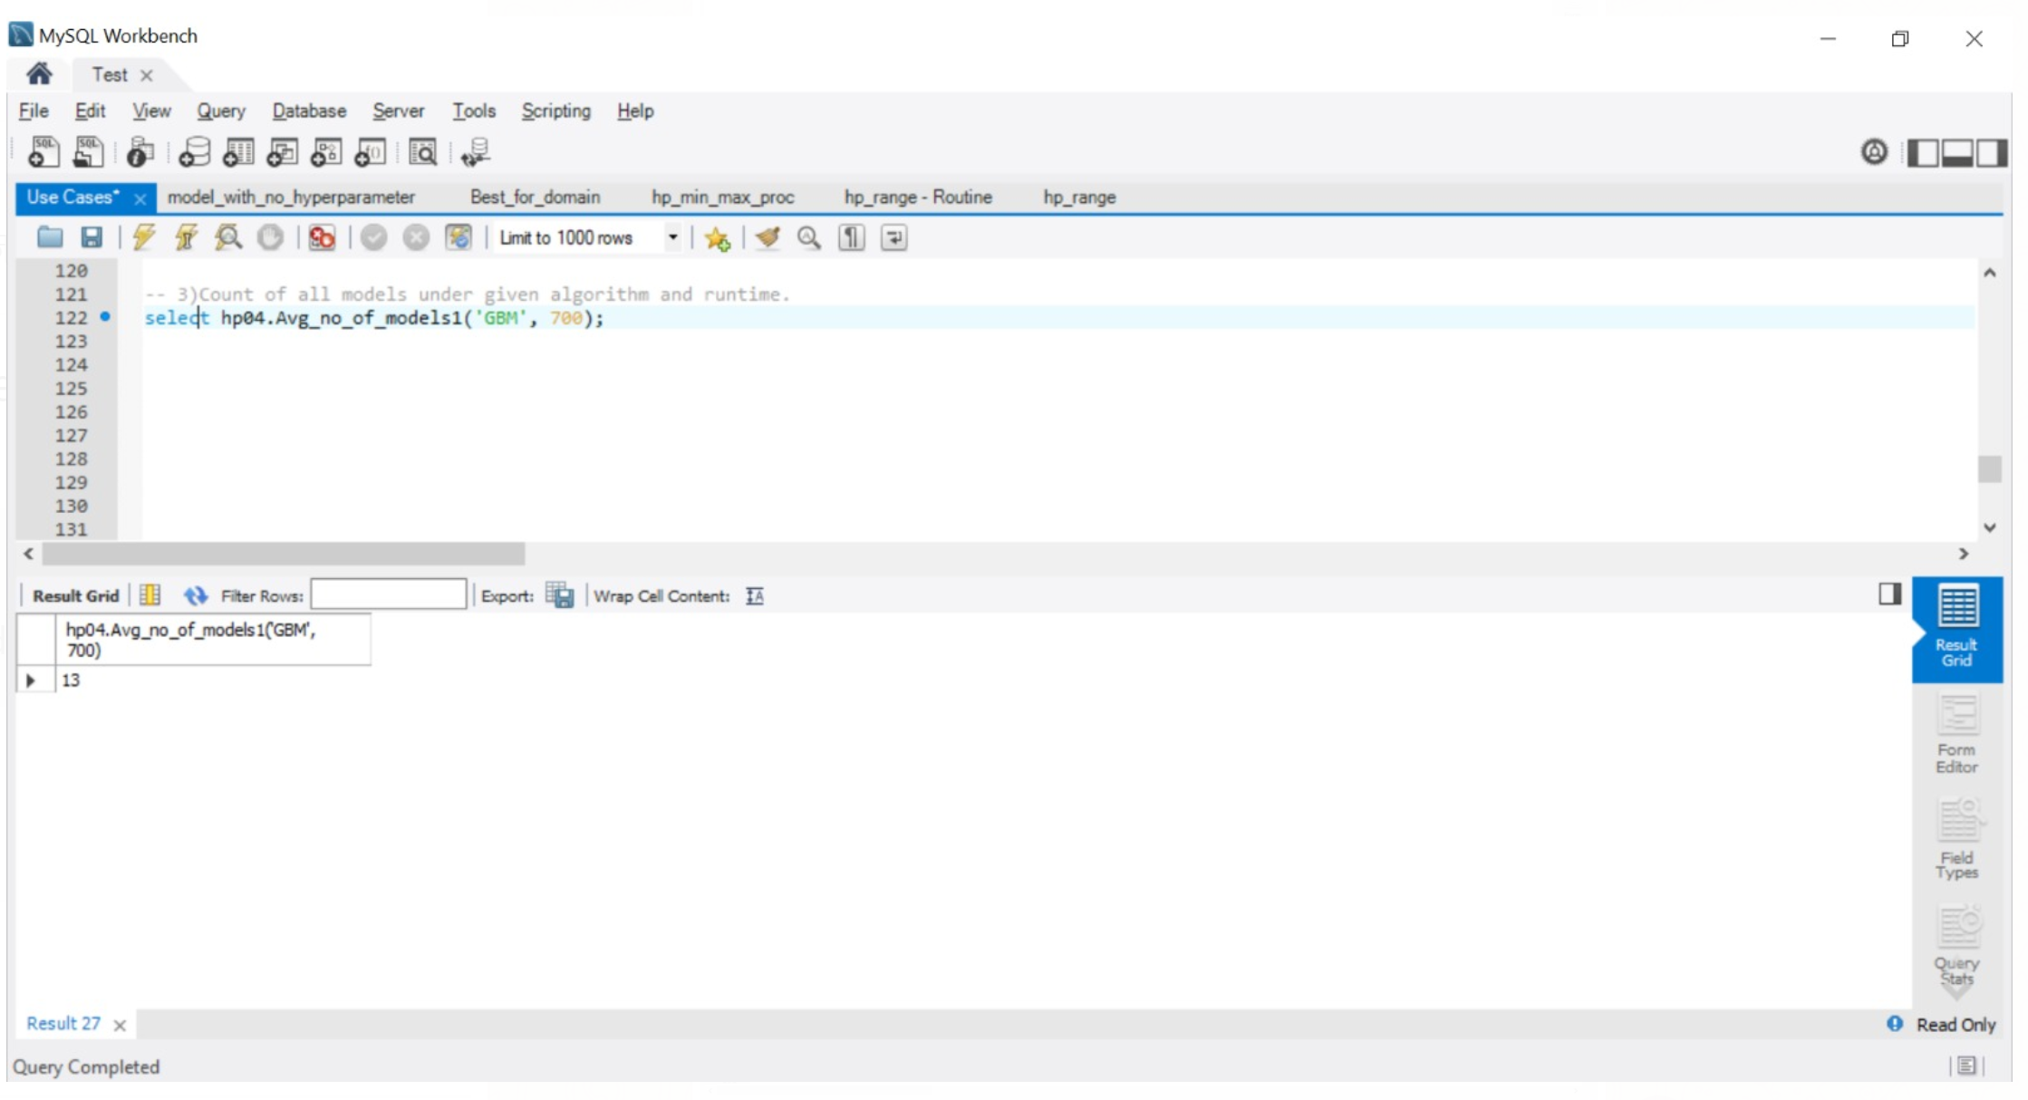

1. What are the actual, default values and the range of learn_rate hyperparameter

Output: All hyperparameter default values

CODE:

DELIMITER $$

CREATE DEFINER=`root`@`localhost` PROCEDURE `hp_range`()

BEGIN

DECLARE default_value varchar(45);

SELECT hyper_def_values INTO default_value from hp04.default_values where HP04 = 'learn_rate';

select learn_rate, default_value, (learn_rate-default_value) as hp_range from hp04.model_gbm;

END$$

DELIMITER ;

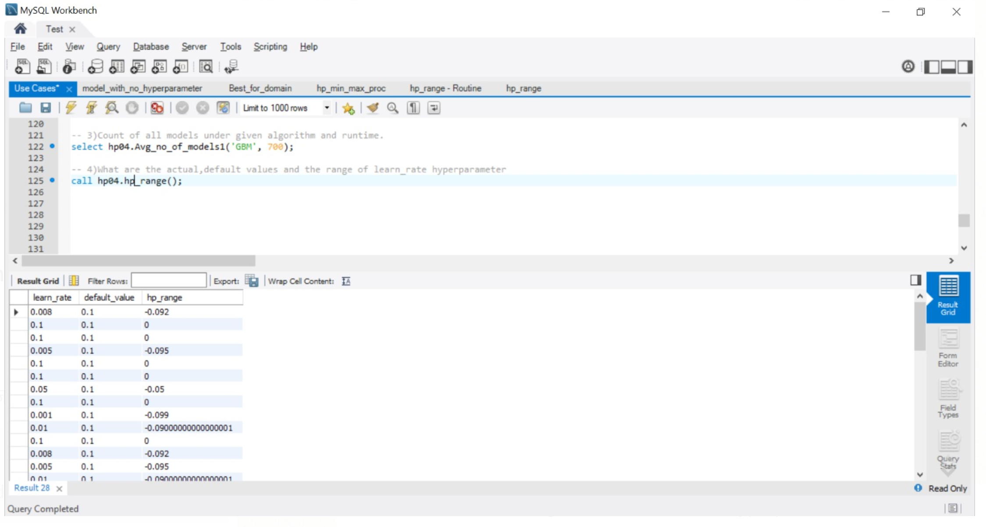

**Views:**

1. View of a list of all the datasets available in the database

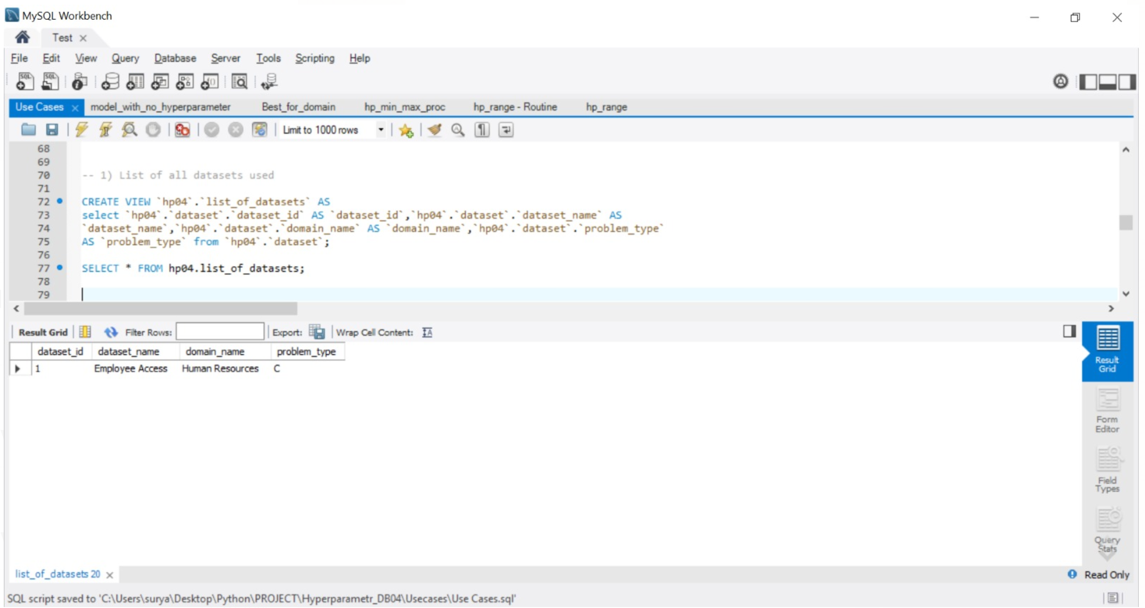

1. List of all runtimes and respective models for those runtimes

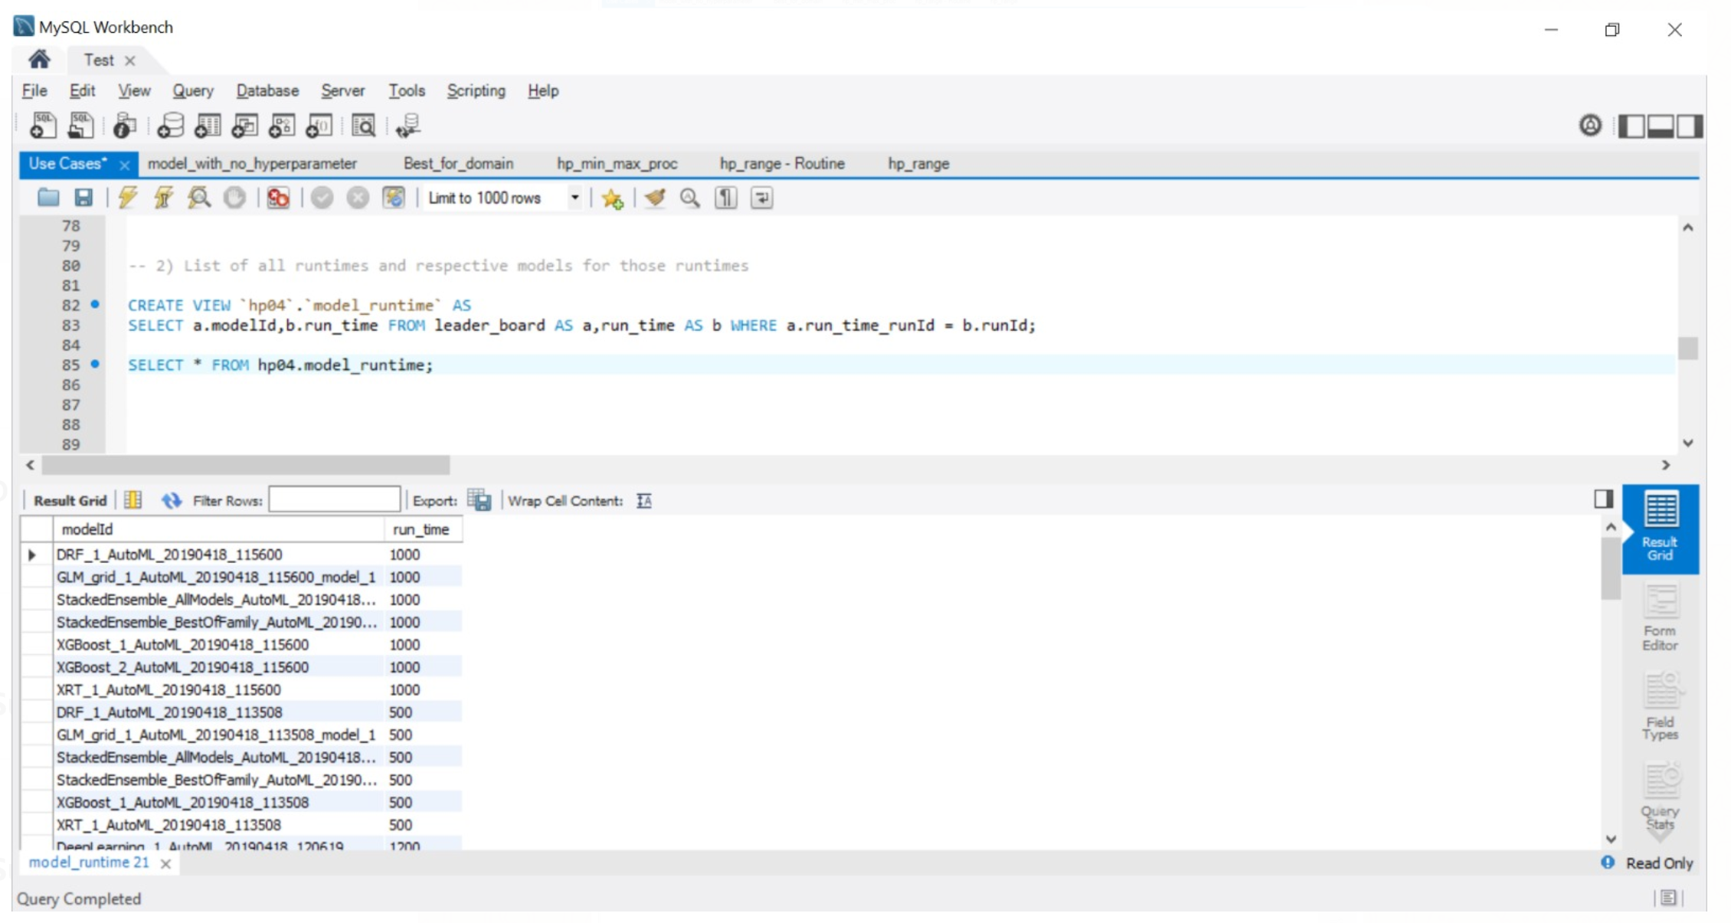

3) All hyperparameters and default values

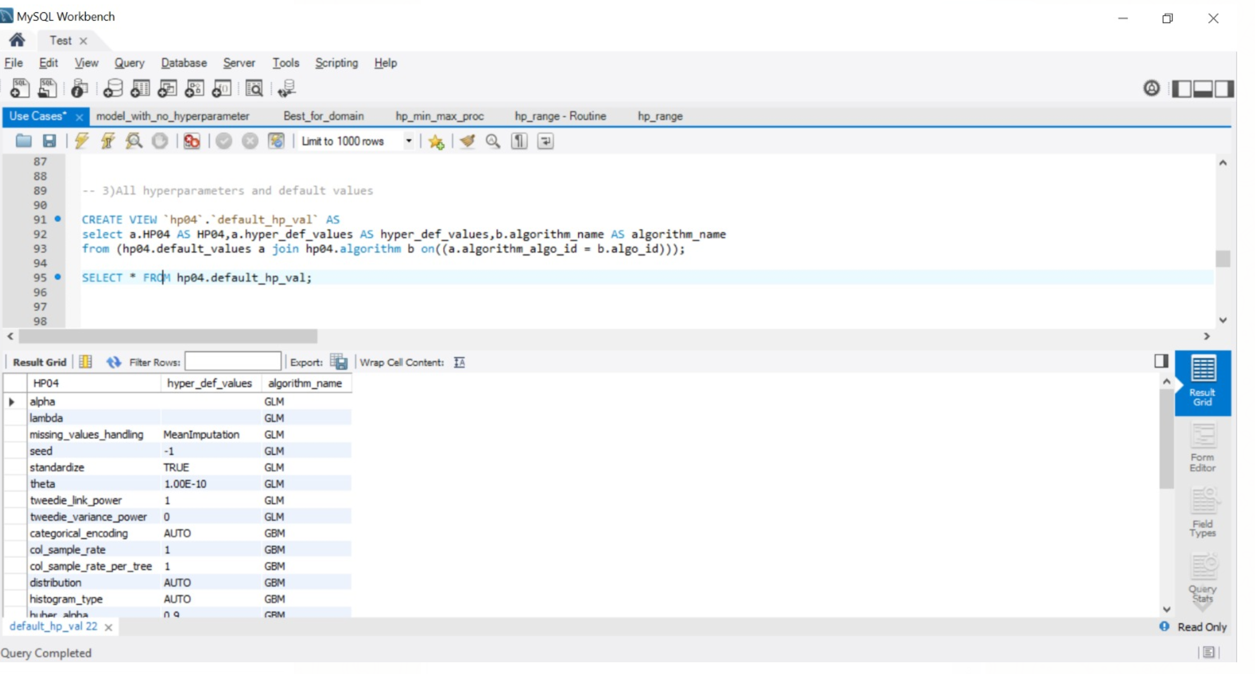

4) All models with no hyperparameters

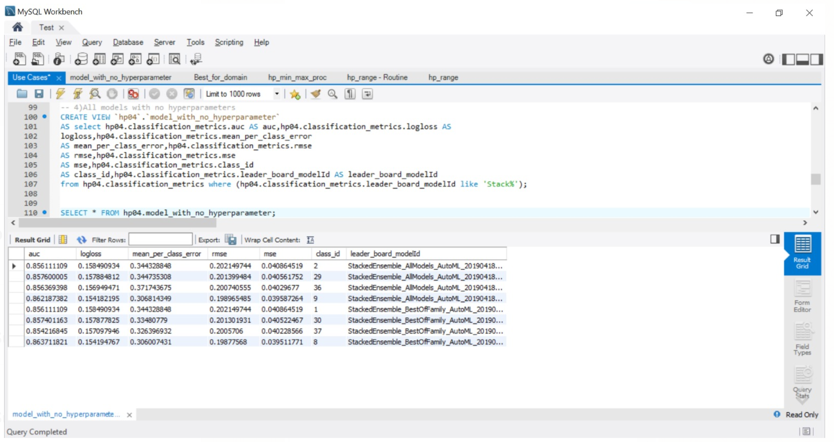

**Conclusion:**

Thus, after the project we were able to create an actual physical database storing the hyperparameters’ actual and default values. Through the demonstration of the use cases, we will be able to support a website for the same. The following points were covered:

1. Conceptual Diagram
2. ER – Diagram
3. Normalization
4. Creating a physical database
5. Use Case preparation
6. Functions
7. Views
8. Stored Procedures

**Citations:**

1. <http://docs.h2o.ai/h2o/latest-stable/h2o-docs/grid-search.html> - H20 Hyperparameters
2. <https://github.com/nikbearbrown/INFO_6210> - Prof. Nik’s Git Hub
3. <http://www.mysqltutorial.org/mysql-stored-procedure-tutorial.aspx> – Stored Procedures
4. <http://www.mysqltutorial.org/mysql-functions.aspx> – Functions

**License:**

Copyright 2019 Tejas Munot, Manasa Vanga

Permission is hereby granted, free of charge, to any person obtaining a copy of this software and associated documentation files (the "Software"), to deal in the Software without restriction, including without limitation the rights to use, copy, modify, merge, publish, distribute, sublicense, and/or sell copies of the Software, and to permit persons to whom the Software is furnished to do so, subject to the following conditions:

The above copyright notice and this permission notice shall be included in all copies or substantial portions of the Software.

THE SOFTWARE IS PROVIDED "AS IS", WITHOUT WARRANTY OF ANY KIND, EXPRESS OR IMPLIED, INCLUDING BUT NOT LIMITED TO THE WARRANTIES OF MERCHANTABILITY, FITNESS FOR A PARTICULAR PURPOSE AND NONINFRINGEMENT. IN NO EVENT SHALL THE AUTHORS OR COPYRIGHT HOLDERS BE LIABLE FOR ANY CLAIM, DAMAGES OR OTHER LIABILITY, WHETHER IN AN ACTION OF CONTRACT, TORT OR OTHERWISE, ARISING FROM, OUT OF OR IN CONNECTION WITH THE SOFTWARE OR THE USE OR OTHER DEALINGS IN THE SOFTWARE.